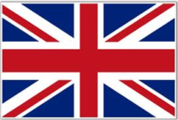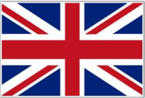

|  |  |  |  |  |
| --- | --- | --- | --- | --- |
| **Country** | **ENGLAND** | **WALES** | **SCOTLAND** | **NORTHERN**  **IRELAND** |
| **Map** |  |  |  |  |
| **Flag** |  |  |  |  |
| **Coat of Arms** |  |  |  |  |
| **Emblem** |  |  |  |  |
| **Patron Saint** |  |  |  |  |
| **National Holiday** | **23rd April** | **1st March** | **30th November** | **17th March** |
| **Language** | **English** | **Welsh** | **Scottish Gaelic** | **Irish Gaelic** |
| **Morning Greeting** | ***Good morning!*** | ***Bore da!*** | ***Madainn mhath!*** | ***Dia duit ar maidin!*** |
| **Capital** | **London** | **Cardiff** | **Edinburgh** | **Belfast** |